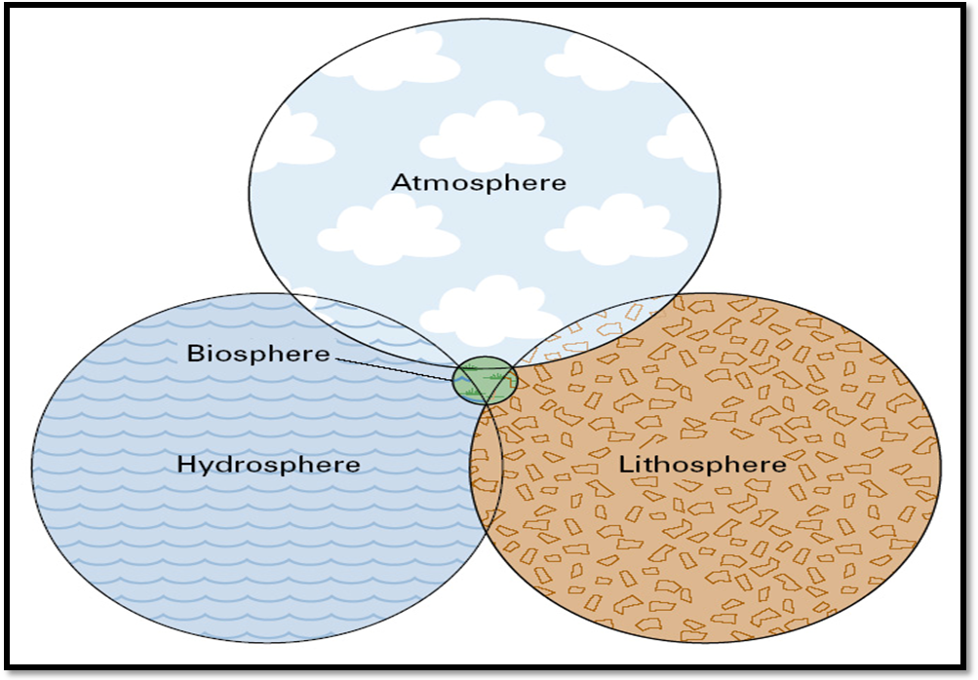

REVIEW QUESTIONS: FINAL EXAM
Physical Geography
Therkalsen

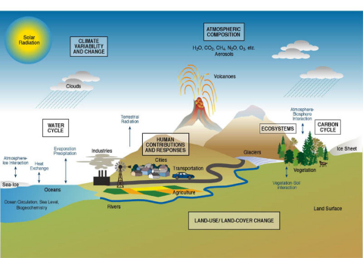

TEST 4 REVIEW QUESTIONS
Rewrite and complete these on a separate sheet of paper to help you study for the test (not for extra credit!)
OCEANOGRAPHY
1. What does the topography of the oceans look like?
- What are the major differences between topography along active continental margins and along passive continental margins?
2. What is salinity/how are “salts” defined? Where do the salts in the ocean come from? What is the average salinity of the oceans?
3. What happens to the properties of water as the salinity changes
- Freezing/boiling points, heat capacity, evaporation rate, and density
4. Graph and explain how a) pressure, b) temperature and c) density changes with ocean depth? Why is density important?
5. What controls deep ocean circulation? What does the general pattern look like?
6. What controls surface water circulation? How do surface currents relate to wind patterns? What is the net water transfer pattern (Ekman transport)?
- Explain the net transport if given a wind direction (i.e. easterly wind=_____ net water transport). Draw some examples.
7. What does ocean current circulation look like? What is a Gyre and which direction do they flow in Northern Hemisphere/Southern? What are the different characteristics of an eastern boundary vs. western boundary current? Sketch a diagram.
8. What is an El Nino event? What are the results on the different sides of the Pacific?
9. Explain the anatomy of a wave (crest, trough, height, length, steepness). What factors determine the height of a wave? What determines the type of wave break?
10. What is the main force (we discussed in class) that influences the movement of tides on earth? What’s the difference between spring tides and neap tides? Draw the diagrams.

HUMAN-ENVIRONMENT INTERACTION
1. What’s the difference between a renewable and non-renewable resource (as defined in class)?
2. Explain where the energy in fossil fuels comes from. What are the problems with fossil fuels?
3. What types of renewable resources maybe alternatives? Explain how they provide energy (trace the energy transformations) and list the pros and cons of each.
4. What type of environmental problems does the atmosphere face? Explain these.
5. What types of problems does the hydrosphere face? Explain these (you should use local examples whenever possible).
6. What types of “land based” problems did we speak about? Explain these.
Explain the concept of “global warming”. Do so by first explaining the greenhouse effect and then explaining how it is related to “global warming.” (Be sure to use the following terms shortwave radiation emission, longwave radiation emission, greenhouse gases, counter radiation)
8. Explain the following in regards to global warming 1. Evidence for, 2. Controversial areas,
9. Explain some of the environmental issues facing California.

MAJOR SUMMATIVE COURSE CONCEPTS TO REVIEW AND KNOW
The final exam is “semi-cumulative” the test will be 25% new material and 75% old material. You should focus on the common themes that have been present throughout each of the sections. Don’t sweat the small stuff – focus on the big picture items (i.e. each section built to a final explanation of a major topic, make sure you can explain each of those “final topics”) Refer to the list below for guidance:
Section One: This section introduced the distribution of energy; you should understand:
A) The laws of thermodynamics and entropy
B) Earth’s global energy balance
- Global energy transfer mechanisms
C) The Earth sun relationship (models) in detail

Section Two: This section was all about the atmosphere, so you should understand:
A) Variables that determine surface temperatures
B) What factors influence the movement of air (Wind/Atm. Pressure)
To test yourself: Practice analyzing surface atmospheric pressure maps. Can you predict weather in locations (high vs low pressure, fronts) with a step by step explanation?
- Sea-breeze model, global wind and pressure (3 cell model)
C) Atmospheric moisture
- The different processes which produce clouds

Section Three: This section covered climate and surface features. Understand:
A) How/Why climates are distributed
- Idealized climate along with climate controls
B) How are different rocks formed (rock cycle)
- Resulting characteristics and examples
To test yourself: use San Diego as an example. Can you name/explain the climate as well as the past and present geologic situation?
C) Plate boundary interactions
- Resulting characteristics and examples

D) External processes wearing down the land

